
BASIC APOLOGETICS
Why We Believe & How to Defend it
1 Peter 3:15: “but in your hearts honor Christ the Lord as holy, always being prepared to make a defense to anyone who asks you for a reason for the hope that is in you; yet do it with gentleness and respect.” | Ready to study?
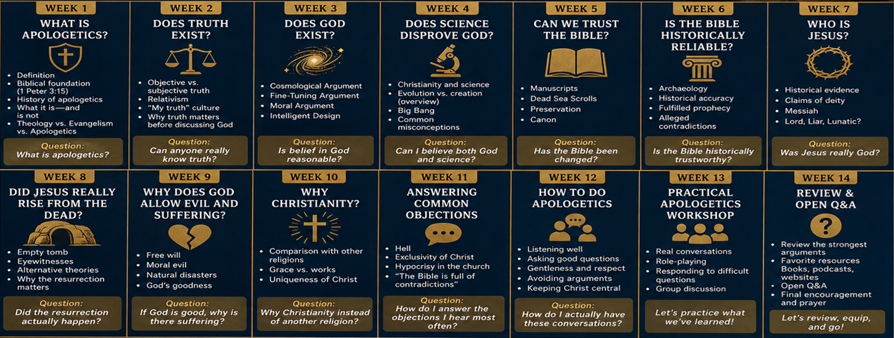
THREE THINGS TO DO  - 1. Learn the gospel. Know what Christianity teaches about God, sin, Jesus, the cross, resurrection, repentance, and faith.  - 2. Practice one answer. Choose one common question, study it carefully, and explain your answer in your own words.  - 3. Start a gracious conversation. Ask good questions, listen closely, and speak with gentleness and respect (1 Peter 3:15).  STARTER BOOKS  The Bible - This is and will always be the most important book to read. It is our lifeline and foundation. Begin with the Gospel of John and Acts.  I Don’t Have Enough Faith to be an Atheist – Norman Geislar & Frank Turek; has a ton of information on basically every topic we will talk about.  Mere Christianity - C. S. Lewis; a classic introduction to Christian belief.  Tactics - Greg Koukl; practical guidance for productive conversations.  Cold-Case Christianity - J. Warner Wallace; a detective's approach to the Gospel evidence.  Reasonable Faith - William Lane Craig; a deeper treatment of arguments and evidence. | PODCASTS TO EXPLORE  Stand to Reason - Short, practical responses to cultural and apologetics questions.  Reasonable Faith - Philosophy, theology, and the case for Christian belief.  Cold-Case Christianity - Evidence for Christianity presented through investigative reasoning.  Unbelievable? - Long-form discussions and debates between Christians and skeptics.  SPEAKERS & TALKS  Greg Koukl - Conversation skills, moral questions, and clear Christian thinking.  William Lane Craig - Arguments for God's existence and the resurrection.  J. Warner Wallace - The historical case for Jesus and the Gospels.  Sean McDowell - Accessible teaching on truth, Scripture, sexuality, and culture.  Frank Turek - Popular-level presentations defending central Christian claims.

WEBSITE
benoitfaith.org
- All PowerPoints
- Lesson Notes
- Daily Study
- Weekly Questions
- Contact Me
- Critiques/Suggestions
Email: jbenoit492@yahoo.com

